Portfolio 1 - Documentation and Ethics Requirements

P Number: P2863788
Name: Tauheed Ahmed Nabil
Individual Component: AI Finder & OMDb Integration
Team Name: CodeFlix(Team-1)

Contents
1. Documentation 3
1.1 Team Class Diagram 3
1.2 Team Use Case Diagram(s)…………………………………………………………………………………………………4
1.3 Individual Use Case Diagram(s)………………………………………………………………………………………….5
1.4 Individual Use Case Descriptions…………………………………………………………………………………..6-10
2. Ethics Case Study 11
2.1 Risk Register 11
2.2 Ethics Checklist 12
3. References 14

Documentation

Team Class Diagram
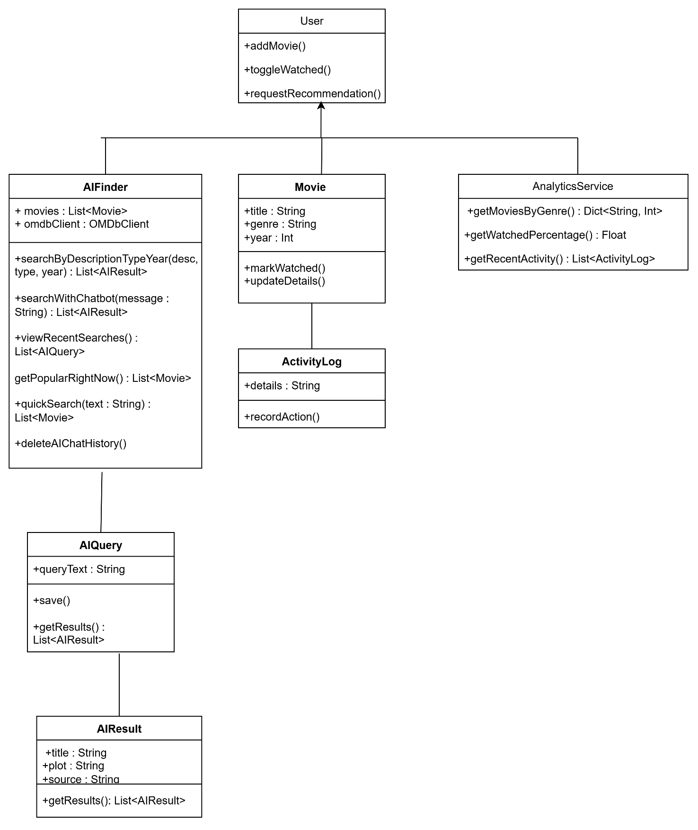

1.2 Team Use Case Diagram(s)
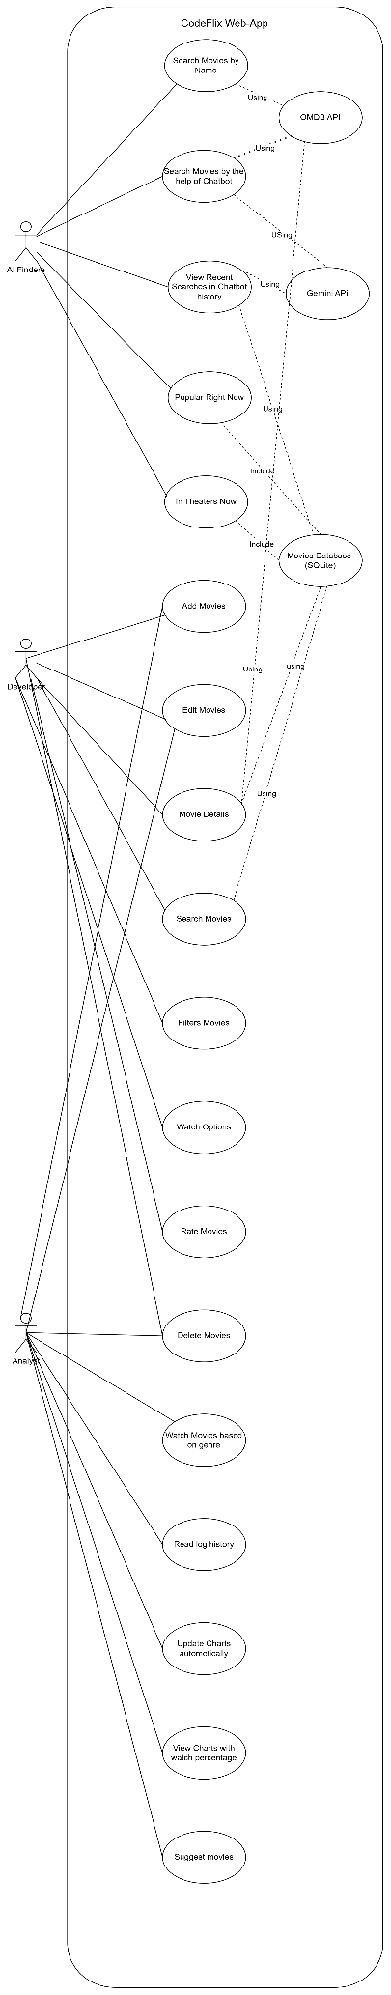

Individual Use Case Diagram(s)

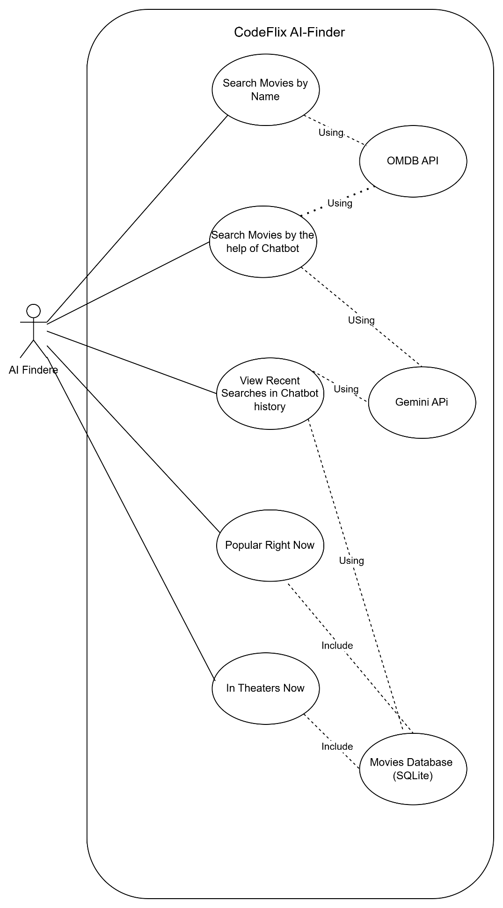

Individual Use Case Descriptions
1.4.1:
Use Case Name | Search Movies by Name
Use Case Author(s) | Tauheed Ahmed Nabil
Primary Actor(s) | AI Finder
Other Stakeholders | OMDB API
Business Goal | Search Movies calling API
Preconditions | Running the Web App properly from Terminal Command
Success Condition | Showing Desired movies
 | Actor | System
Primary pathway | 1. User opens the AI Finder page | 2. Shows search box
 | 3. User types keyword “Title” | 4. Validates input
 | 5. User clicks “Search” | 6. Sends request to OMDB API and shows movie list
Alternate pathways | Go to “Watch Now” page and search the movie | 4a. Shows search box  4b. Sends request to OMDB API and shows movie list
Exception pathways | Shows Mavie title in bracket with sample (i.e. searching “Holla” will show result like Holla (Sample) (2023))

1.4.2:

Use Case Name | Search Movies by the help of Chatbot
Use Case Author(s) | Tauheed Ahmed Nabil
Primary Actor(s) | AI Finder
Other Stakeholders | OMDB API, Gemini API
Business Goal | Search Movies suggesting mood or any plot or title calling API keys with a relatable joke at the end
Preconditions | Running the Web App properly from Terminal Command
Success Condition | Search Movies suggesting mood or any plot or title
 | Actor | System
Primary pathway | 1. User opens the AI Finder page | 2.Shows Chatbot
 | 3. User writes relatable text | 4.Validates Input
 | 5.User click the arrow sign or press enter on keyboard | 6. Sends request to OMDB API along with Gemini API and shows movie list with a joke at the end
Alternate pathways | N/A | N/A
Exception pathways | N/A | N/A

1.4.3:

Use Case Name | View Recent Searches in Chatbot history
Use Case Author(s) | Tauheed Ahmed Nabil
Primary Actor(s) | AI Finder
Other Stakeholders | Gemini API, Movies Database  (SQLite), OMDB API
Business Goal | View Recent Searches in Chatbot history
Preconditions | Running the Web App properly from Terminal Command
Success Condition | View Recent Searches in Chatbot history
 | Actor | System
Primary pathway | 1. User opens the AI Finder page | 2. Shows Chatbot
 | 3. Use Chatbot multiple times like the second use case called “Search Movies by the help of Chatbot” | 4. Sends request to OMDB API along with Gemini API and shows movie list with a joke at the end per uses
 | 5.Shows Chatbot search result Chronologically per using like the first search history will be seen at the top of chatbot area | 6. Sends request to OMDB API along with Gemini API and shows movie list with a joke at the end and call the SQLite database for showing Chat history
Alternate pathways | N/A | N/A
Exception pathways | N/A | N/A

1.4.4:

Use Case Name | Popular Right Now
Use Case Author(s) | Tauheed Ahmed Nabil
Primary Actor(s) | AI Finder
Other Stakeholders | Movies Database  (SQLite)
Business Goal | Showing Popular Movie list
Preconditions | Running the Web App properly from Terminal Command
Success Condition | Showing Desired movies
 | Actor | System
Primary pathway | 1. User opens the AI Finder page | 2. Shows Popular Movie list
 | 3. Choose Movie | 4. Validates input
 | 5. User clicks Movie Title | 6. Sends request to Movies Database (SQLite) and Show movie details
Alternate pathways | N/A | N/A
Exception pathways | N/A | N/A

1.4.5:

Use Case Name | In Theatres Now
Use Case Author(s) | Tauheed Ahmed Nabil
Primary Actor(s) | AI Finder
Other Stakeholders | Movies Database  (SQLite)
Business Goal | Showing Movie list Showing in Theatres
Preconditions | Running the Web App properly from Terminal Command
Success Condition | Showing Desired movies
 | Actor | System
Primary pathway | 1. User opens the AI Finder page | 2. Shows “In Theatres Now” list
 | 3. Choose Movie | 4. Validates input
 | 5. User clicks Movie Title | 6. Sends request to Movies Database (SQLite) and Show movie details
Alternate pathways | Go to the bottom of the “Dashboard” page and use the same feature | Sends request to Movies Database (SQLite) and Show movie details
Exception pathways | N/A | N/A

Ethics Case Study

Risk Register
Risk Assessment
H | High-unacceptable risk; major disruption likely; different approach required; priority management attention required.
M | Moderate risk; some disruption; different approach may be required; additional management attention.
L | Low/minimum risk; minimum oversight needed to ensure risk remains low

Scoring: IMPACT LIKELIHOOD (L)
1 = Insignificant 1 = Rare
2 = Minor 2 = Unlikely
3 = Moderate 3 = Possible
4 = Major 4 = Likely
5 = Catastrophic 5 = Almost Certain

Risk | Likelihood | Impact | Proposed risk-mitigation measure
AI Chatbot Working Proficiency | M3 | H1 | Use the chatbot multiple times or go to AI Finder Search option or “Watch Now” page and search movies from there
AI Search bar Working Proficiency | L1 | L2 | Go to “Watch Now” page and search movies from there
Running the web-app | M3 | M3 | Run and install every command exactly same as shown in the readme section about running the web app
Installing wrong Python version | H3 | H1 | Install Python 3.12 and choose add on pathway option while installing
Installing correct Dependencies | H3 | H1 | Install all the dependencies application separately by giving correct terminal command (i.e. pip install streamlit)
Creating Virtual environment | H3 | H1 | Delete existing virtual environment related files if shown in the work folder initially before setting up the environment
Command error | H1 | H5 | Write the correct command with correct typing in the terminal.
Seed data | L2 | H3 | Seed the database before running the app through command in the installing period

Ethics Checklist

Key Principle | Rationale | How has it been addressed or could be addressed
Transparency: Transparency is essential in the development of ethical software. | This means users should understand how their data is collected, processed, and stored. As a developer, you should offer clear and accessible documentation regarding your software’s capabilities, limitations, and potential risks. This openness creates trust between developers and users, allowing them to make informed decisions about their data and engagement with the platform. | We maintain full transparency by clearly explaining what data CodeFlix stores (movie name, genre, watched status, user queries) and why. In the project documentation, we describe how the AI Finder works, when it uses local matching vs OMDb and Gemini API, and what information is logged. Users are informed that no sensitive personal data is collected. All system limitations and features are openly documented so users can trust the platform
Privacy: Privacy is a fundamental right software must respect. | As a developer, you should only collect the data required for your application’s intended purpose following the data minimization principles and acquire informed consent from users. | CodeFlix follows data-minimisation principles. We only collect the data needed to provide the movie watchlist and AI recommendation features. No personal information (like passwords, phone numbers, or location) is stored. AI queries and activity logs only save simple text and timestamps, and we avoid any sensitive or identifiable data. If this system became public, we would include a privacy notice and ask for user consent before storing logs.
Security: In ethical software development, security is paramount | Software should be planned and produced throughout the development lifecycle, with security a high concern. Developers should follow best practices to identify, avoid, and mitigate vulnerabilities. | Security is ensured by using parameterised SQL queries (preventing SQL injection), a local SQLite database, and limited data storage. No external sensitive data is stored. Dependencies such as OMDb and Gemini API requests are handled safely without exposing API keys publicly (using a secrets file). This web-app is mainly built This project is designed more for companies than for general end-users. The idea is that a company can look at our work, get inspired, and take specific parts, such as the AI Finder feature and integrate those components into their own existing systems. If the project expanded, we would add encryption, user authentication, and regular security checks to further protect the system.
Fairness: Fairness ensures that software does not discriminate against any group or individual. | Algorithms and decision-making processes should be free of bias and not increase or perpetuate social and economic imbalances. Developers must use approaches to discover and reduce biases in algorithms and data. | CodeFlix avoids discrimination because it does not collect or process any personal demographic data. All movie recommendations are generated solely from user text queries or database search results, not from personal profiles. The AI Finder uses neutral algorithms such as TF-IDF(term frequency and inverse document frequency) and OMDb data, reducing the risk of bias. If we expanded the system, we would test the AI suggestions to ensure they do not favour or exclude certain groups.
Accountability: The effects of software on people and society are the responsibility of its developers. | As developers, we must be accountable for any unfavourable outcomes and be open and honest about growth procedures. Clear methods for reporting ethical concerns should be established, and any ethical issues should be addressed as soon as possible | We take responsibility for the behaviour of the system through activity logs that track AI queries and operations. Any errors, unexpected behaviours, or incorrect recommendations can be traced and fixed. Our documentation is honest about the system limitations (e.g., AI suggestions might not always be accurate). If the system were deployed for the public, we would provide a feedback/reporting method so users can raise ethical or functional concerns quickly
https://blog.openreplay.com/ethical-considerations-in-software-development/

References

- Why we have chosen “Streamlit” for this project: https://youtu.be/H0JfZDXStKY?si=CMB3qvlH2ZIwjKiW
- Streamlit Project Inspiration:
https://youtu.be/o8p7uQCGD0U?si=MPG5k7qZYhFu9tWi
https://www.youtube.com/watch?v=Vh4-rU6VIFk&list=PLTsu3dft3CWhBViLMhL0Aqb75rkSz_CL-

- AI chatbot Inspiration:
https://www.youtube.com/watch?v=ZaUcqznlhv8&list=PLqFaTIg4myu9r7uRoNfbJhHUbLp-1t1YE
- Use-Case Diagram:
https://www.geeksforgeeks.org/system-design/use-case-diagram/
- Class Diagram:
https://www.geeksforgeeks.org/system-design/unified-modeling-language-uml-class-diagrams/

